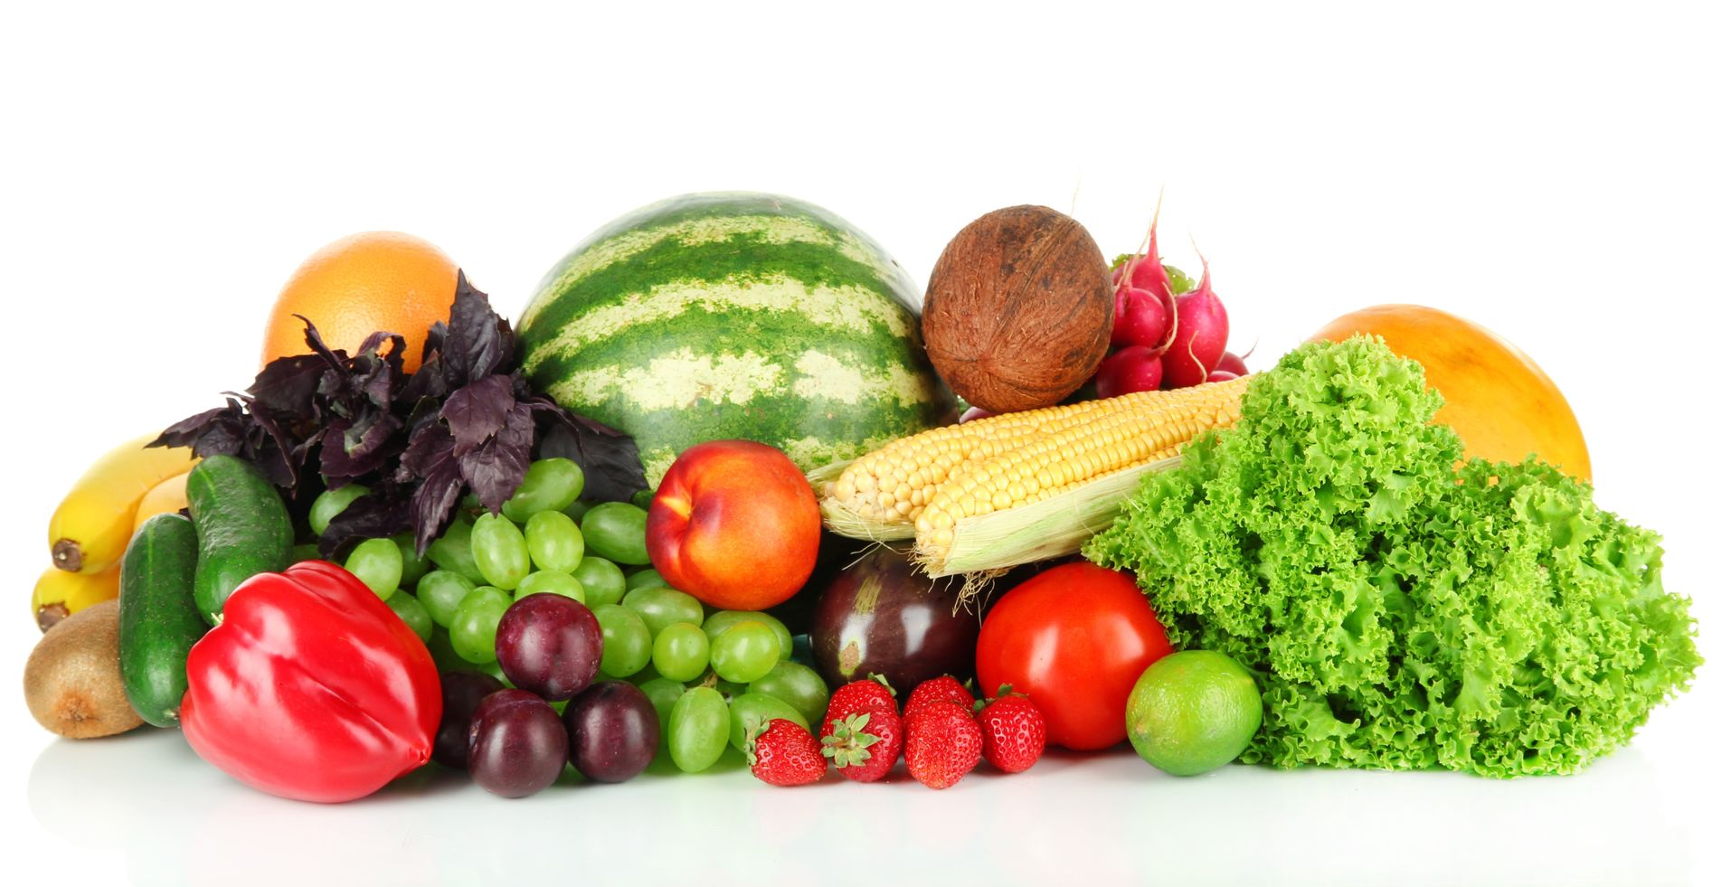
The fruits of life in the Holy Spirit
are as rich and varied
as the fruits of autumn.
What gifts has the Spirit given
to enrich the lives
of people in our community?
What are the fruits borne
by your life in the Holy Spirit?
What are the fruits of the life
of our community?
And who benefits from them?

